|  |  |
| --- | --- |
| Course – Section | Computer Networks (CS3001 - Fall 2023) – *BDS-7A, BSE-7A*, *BSR-5A* |
| Assignment Num. | 03 |
| Total Marks | **60** |
| Start Date | 17-October-2023 |
| Due Date/Time | 26-October-2023 (12:30 PM) |
| Submission | ***Submit the handwritten assignment in L-109, 1st floor, Library Building*** |
| Author | Muhammad Hashim Bilal Qureshi ([l201219@lhr.nu.edu.pk](mailto:l201219@lhr.nu.edu.pk)) |
| Teacher | Ms. Umme Ammarah ([umme.ammarah@nu.edu.pk](mailto:umme.ammarah@nu.edu.pk)) |
| Submission Guidelines | * *Assignments must be received before the deadline. Submissions after the deadline will face a 25% grade penalty (within 1 day) or a 50% grade penalty (within 2 days).* * *Please do the work by yourself, this is an individual assignment.* * *Plagiarism cases will be dealt with strictly.* |

1. Suppose the network layer provides the following service. The network layer in the source host accepts a segment of maximum size 1,200 bytes and a destination host address from the transport layer. The network layer then guarantees to deliver the segment to the transport layer at the destination host. Suppose many network application processes can be running at the destination host.
   1. Design the simplest possible transport-layer protocol that will get application data to the desired process at the destination host. Assume the operating system in the destination host has assigned a 4-byte port number to each running application process.
   2. Modify this protocol so that it provides a “return address” to the destination process.
   3. In your protocols, does the transport layer “have to do anything” in the core of the computer

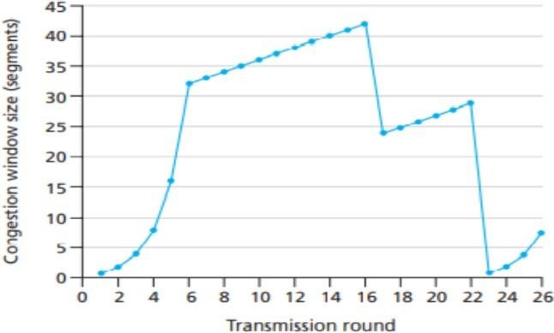network.

# (8 marks)

1. For the figure given below, assume TCP Reno is the protocol experiencing the behavior shown.
   1. Identify the intervals of time when TCP slow start is operating.
   2. Identify the intervals of time when TCP congestion avoidance is operating.
   3. After the 16th transmission round, is segment loss detected by a triple duplicate ACK or by atimeout?
   4. After the 22nd transmission round, is segment loss detected by a triple duplicate ACK or by a timeout?
   5. What is the initial value of *ssthresh* at the first transmission round?
   6. What is the value of *ssthresh* at the 18th transmission round?
   7. What is the value of *ssthresh* at the 24th transmission round?
   8. During what transmission round is the 70th segment sent?
   9. Assuming a packet loss is detected after the 26th round by the receipt of a triple duplicate ACK, what will be the values of the congestion window size and of *ssthresh*?

# (8 marks)

1. Consider a planet where everyone belongs to a family of six, every family lives in its own house, each house has a unique address, and each person in each house has a unique name. Suppose this planet has a mail service that delivers letters from source house to destination house. The mail service requires that
2. the letter be in an envelope, and that (2) the address of the destination house (and nothing more) be clearly written on the envelope. Suppose each family has a delegate family member who collects and distributes letters for the other family members. The letters do not necessarily provide any indication of the recipients of the letters.
   1. Describe a protocol that the delegates can use to deliver letters from a sending family member to a receiving family member.
   2. In your protocol, does the mail service ever have to open the envelope and examine the letter to provide its service?

# (8 marks)

1. 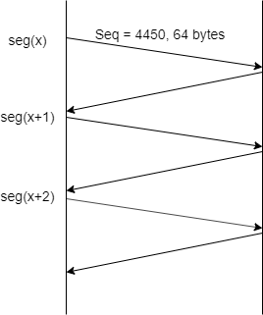Suppose Node A (sender) and B (receiver) have a TCP connection between them. Assume that a single segment, i.e., seg(x-1) is timed-out. Consider the size of the TCP receiver buffer is 300 bytes. Assuming all packets of equal size i.e., 64 bytes, if *ssthreshold* = 6, then **answer the following questions** by looking at the figure provided below, by providing:
   1. Sequence number of seg(x+2)
   2. Acknowledgement of seg(x+2)
   3. Sequence number of bytes of seg(x+4)
   4. *Receiver window* field value in acknowledgment of seg(x+3)
   5. *Receiver window* field value in acknowledgement of seg(x+4)
   6. Value of *window size* and *ssthreshold* after acknowledgement of seg(x+6) is received?
   7. TCP receiver sometimes waits for 500ms before sending an acknowledgement of a newly arrived segment. For how long will receiver wait before sending ack for seg(x+4)?
   8. Assuming seg(x) to be sent in the first transmission round, how many segments will be sent in the third transmission round?
   9. Assume no loss occurs, what will be the last segment that will be sent in the *slow start* phase starting from seg(x)?
   10. What is the link utilization during the *slow start* phase if the link capacity is 10 Mbps and the RTT between node A and B is 15ms?
   11. Suppose after receiving 50 segments from the source, node B lost synchronization with A. Write the name and value of the field used by destination B to notify source node A.

***NOTE: Answer all numbers in decimal number system ONLY (where applies). For segment numbers, use the notation of seg(x) where x is the number of a segment.***

# (10 marks)

1. Suppose that TCP's current estimated values for the round-trip time (estimated RTT) and deviation in the RTT (Dev RTT) are 210 msec and 49 msec, respectively. Suppose that the next two measured values of the RTT are 280, 210. Compute TCP's new value of estimated RTT, Dev RTT, and the TCP timeout value after each of these three measured RTT values is obtained. Use the values of α = 0.125 and β = 0.25.

# (6 marks)

1. UDP and TCP use 1s complement for their checksums. Suppose you have the following three 8-bit bytes: 01010011, 01100110, 01110100. What is the 1s complement of the sum of these 8-bit bytes? (Note that although UDP and TCP use 16-bit words in computing the checksum, for this problem you are being asked to consider 8-bit sums.) Show all work. Why is it that UDP takes the 1s complement of the sum; that is, why not just use the sum? With the 1s complement scheme, how does the receiver detect errors? Is it possible that a 1-bit error will go undetected? How about a 2-bit error?

# (6 marks)

1. Host A and B are communicating over a TCP connection, and Host B has already received from Host A all bytes up through byte 126. Suppose Host A then sends two segments to Host B back-to-back. The first and second segments contain 80 and 40 bytes of data, respectively. In the first segment, the sequence number is 127, the source port number is 302, and the destination port number is 80. Host B sends an acknowledgment whenever it receives a segment from Host A.
   1. In the second segment sent from Host A to B, what are the sequence number, source port number, and destination port number?
   2. If the first segment arrives before the second segment, in the acknowledgment of the first arriving segment, what is the acknowledgment number, the source port number, and the destination port number?
   3. If the second segment arrives before the first segment, in the acknowledgment of the first arriving segment, what is the acknowledgment number?
   4. Suppose the two segments sent by A arrive in order at B. The first acknowledgment is lost, and the second acknowledgment arrives after the first timeout interval. Draw a timing diagram, showing these segments and all other segments and acknowledgments sent (***assume there is no additional packet loss***). For each segment in your figure, provide the sequence number and the number of bytes of data; for each acknowledgment that you add, provide the acknowledgment number.

# (8 marks)

1. Consider a channel that can lose packets but has a maximum delay that is known. Modify protocol RDT 2.1 to include sender timeout and retransmit. Informally argue why your protocol can communicate correctly over this channel.

# (6 marks)

(Good Luck)